Pizza Sales SQL Queries

1. KPI’s
2. Total Revenue:

SELECT

SUM(total_price) AS Total_Revenue

FROM

pizza_sales;

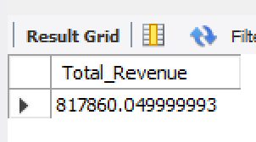

1. Average Order Value:

SELECT

SUM(total_price) / COUNT(DISTINCT order_id) AS Avg_Order_Value

FROM

pizza_sales;

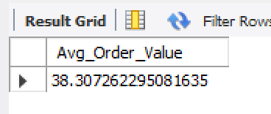

1. Total Pizzas Sold:

SELECT

SUM(quantity) AS Total_Pizza_Sold

FROM

pizza_sales;

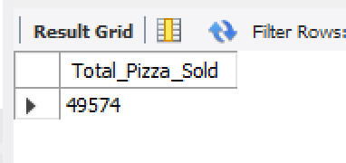

1. Total Orders:

SELECT

COUNT(DISTINCT order_id) AS Total_Orders

FROM

pizza_sales;

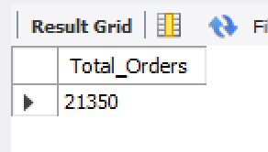

1. Average Pizzas Per Order:

SELECT

CAST(SUM(quantity) / COUNT(DISTINCT order_id) AS DECIMAL (10 , 2 )) AS Avg_Pizzas_Per_Order

FROM

pizza_sales;

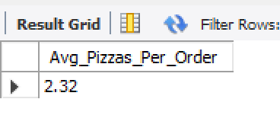

1. Daily Trend for Total Orders:

SELECT

DAYNAME(STR_TO_DATE(order_date, '%d-%m-%Y')) AS order_day,

COUNT(DISTINCT order_id) AS total_orders

FROM

pizza_sales

WHERE

order_date IS NOT NULL

GROUP BY order_day

ORDER BY FIELD(order_day,

'Monday',

'Tuesday',

'Wednesday',

'Thursday',

'Friday',

'Saturday',

'Sunday');

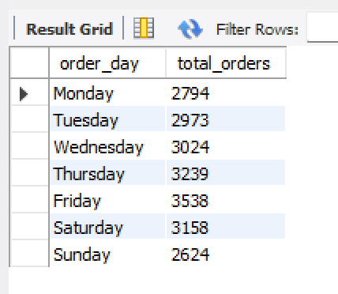

1. Monthly Trend for Total Orders:

SELECT

MONTHNAME(STR_TO_DATE(order_date, '%d-%m-%Y')) AS Month_Name,

COUNT(DISTINCT order_id) AS Total_Orders

FROM

pizza_sales

WHERE

order_date IS NOT NULL

GROUP BY

MONTHNAME(STR_TO_DATE(order_date, '%d-%m-%Y')), MONTH(STR_TO_DATE(order_date, '%d-%m-%Y'))

ORDER BY

Total_Orders DESC;

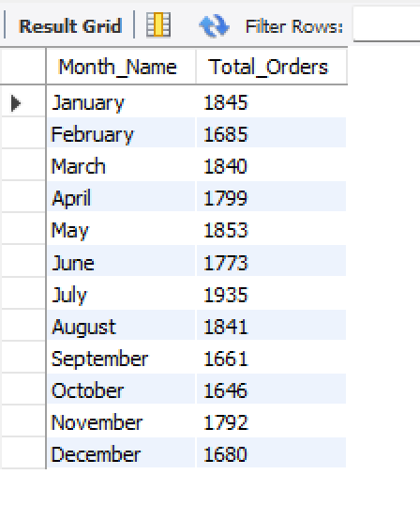

1. **% of Sales by Pizza Category**

SELECT

pizza_category,

SUM(total_price) AS Total_Sales,

SUM(total_price) * 100 / NULLIF((SELECT SUM(total_price) FROM pizza_sales), 0) AS PCT

FROM

pizza_sales

GROUP BY pizza_category;

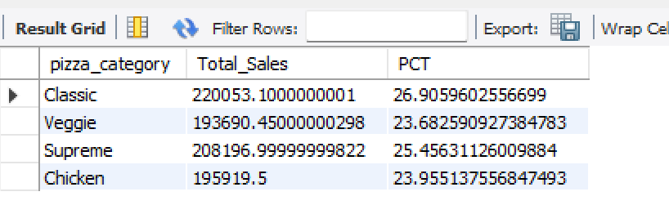

-- FOR ONE MONTH

SELECT

pizza_category,

SUM(total_price) AS Total_Sales,

SUM(total_price) * 100 / NULLIF((SELECT

SUM(total_price)

FROM

pizza_sales

WHERE

MONTH(STR_TO_DATE(order_date, '%d-%m-%Y')) = 1),

0) AS PCT

FROM

pizza_sales

WHERE

MONTH(STR_TO_DATE(order_date, '%d-%m-%Y')) = 1

GROUP BY pizza_category;

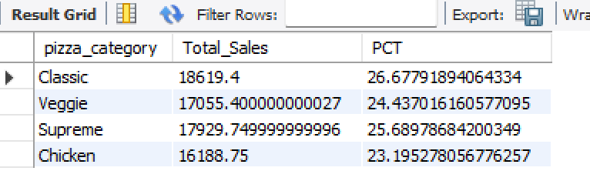

1. % of Sales by Pizza Size

SELECT

pizza_size,

CAST(SUM(total_price) AS DECIMAL(10,2)) AS Total_Sales,

CAST(SUM(total_price) * 100 / NULLIF((SELECT SUM(total_price) FROM pizza_sales), 0) AS DECIMAL(10, 2)) AS PCT

FROM

pizza_sales

GROUP BY pizza_size

ORDER BY PCT DESC;

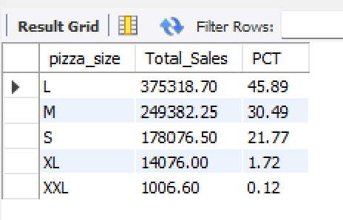

-- FOR ONE QUARTER

SELECT

pizza_size,

CAST(SUM(total_price) AS DECIMAL(10, 2)) AS Total_Sales,

CAST(SUM(total_price) * 100 / NULLIF((SELECT SUM(total_price) FROM pizza_sales), 0) AS DECIMAL(10, 2)) AS PCT

FROM

pizza_sales

WHERE

MONTH(STR_TO_DATE(order_date, '%d-%m-%Y')) IN (1, 2, 3) -- Filter for January, February, March

GROUP BY

pizza_size

ORDER BY

PCT DESC;

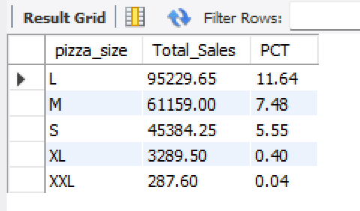

1. **Total Pizzas Sold by Pizza Category**

SELECT

pizza_name, SUM(total_price) AS Total_Revenue

FROM

pizza_sales

GROUP BY pizza_name

ORDER BY Total_Revenue DESC;

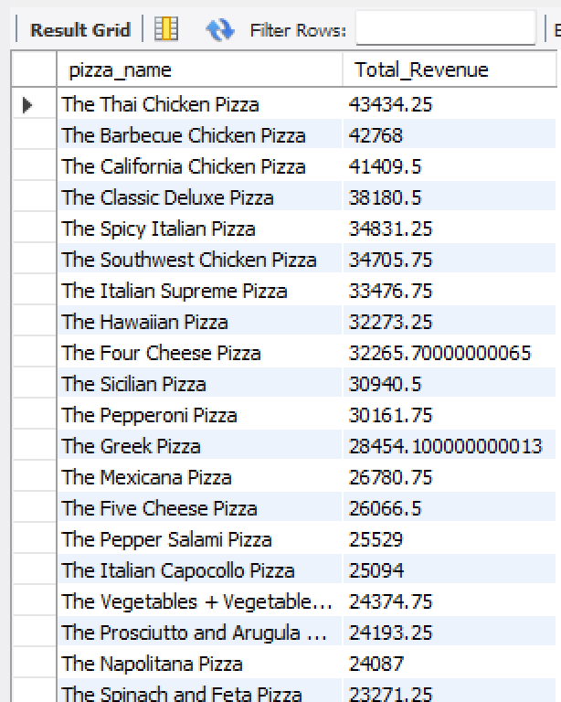

1. **Top 5 Pizzas by Revenue:**

SELECT

pizza_name,

SUM(total_price) AS Total_Revenue

FROM

pizza_sales

GROUP BY

pizza_name

ORDER BY

Total_Revenue DESC

LIMIT 5; -- Limit the results to the top 5

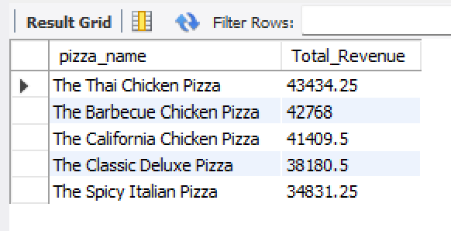

1. Bottom 5 Pizzas by Revenue:

SELECT

pizza_name,

SUM(total_price) AS Total_Revenue

FROM

pizza_sales

GROUP BY

pizza_name

ORDER BY

Total_Revenue ASC -- Sort in ascending order for bottom revenue

LIMIT 5; -- Limit the results to the bottom 5

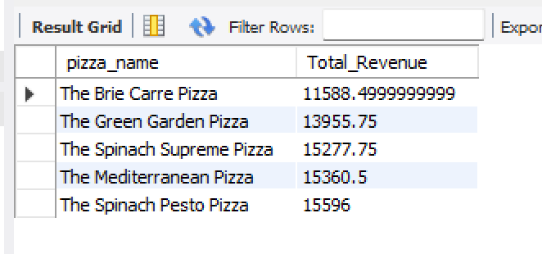

1. Top 5 Pizzas by Quantity:

SELECT

pizza_name,

sum(quantity) AS Total_Quantity

FROM

pizza_sales

GROUP BY

pizza_name

ORDER BY

Total_Quantity DESC

LIMIT 5; -- Limit the results to the top 5

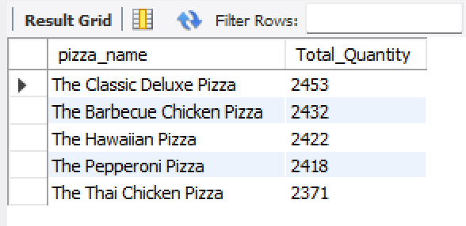

1. Bottom 5 Pizzas by Quantity:

SELECT

pizza_name,

SUM(quantity) AS Total_Quantity

FROM

pizza_sales

GROUP BY

pizza_name

ORDER BY

Total_Quantity ASC -- Sort in ascending order for bottom revenue

LIMIT 5; -- Limit the results to the bottom 5

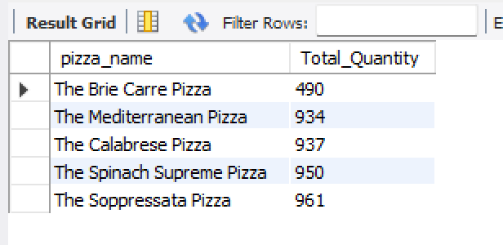

1. Top 5 Pizzas by Total Orders:

SELECT

pizza_name, COUNT(DISTINCT order_id) AS Total_Orders

FROM

pizza_sales

GROUP BY pizza_name

ORDER BY Total_Orders DESC

LIMIT 5; -- Limit the results to the top 5

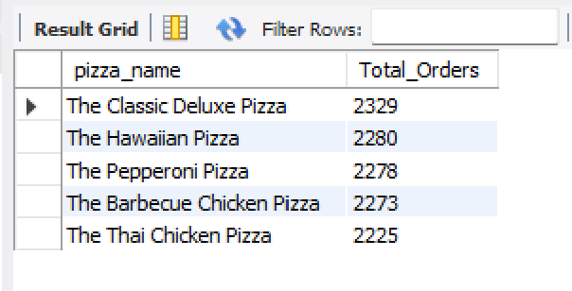

1. Bottom 5 Pizzas by Total Orders:

SELECT

pizza_name, COUNT(DISTINCT order_id) AS Total_Orders

FROM

pizza_sales

GROUP BY pizza_name

ORDER BY Total_Orders

LIMIT 5; -- Limit the results to the top 5

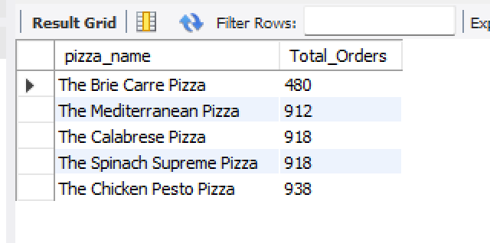

-- A. KPI’s

-- 1. Total Revenue:

SELECT

SUM(total_price) AS Total_Revenue

FROM

pizza_sales;

-- 2. Average Order Value:

SELECT

SUM(total_price) / COUNT(DISTINCT order_id) AS Avg_Order_Value

FROM

pizza_sales;

-- 3. Total Pizzas Sold:

SELECT

SUM(quantity) AS Total_Pizza_Sold

FROM

pizza_sales;

-- 4. Total Orders:

SELECT

COUNT(DISTINCT order_id) AS Total_Orders

FROM

pizza_sales;

-- 5. Average Pizzas Per Order:

SELECT

CAST(SUM(quantity) / COUNT(DISTINCT order_id) AS DECIMAL(10, 2)) AS Avg_Pizzas_Per_Order

FROM

pizza_sales;

-- B. Daily Trend for Total Orders:

SELECT

DAYNAME(STR_TO_DATE(order_date, '%d-%m-%Y')) AS order_day,

COUNT(DISTINCT order_id) AS total_orders

FROM

pizza_sales

WHERE

order_date IS NOT NULL

GROUP BY

order_day

ORDER BY

FIELD(order_day, 'Monday', 'Tuesday', 'Wednesday', 'Thursday', 'Friday', 'Saturday', 'Sunday');

-- C. Monthly Trend for Total Orders:

SELECT

MONTHNAME(STR_TO_DATE(order_date, '%d-%m-%Y')) AS Month_Name,

COUNT(DISTINCT order_id) AS Total_Orders

FROM

pizza_sales

WHERE

order_date IS NOT NULL

GROUP BY

MONTHNAME(STR_TO_DATE(order_date, '%d-%m-%Y')),

MONTH(STR_TO_DATE(order_date, '%d-%m-%Y'))

ORDER BY

Total_Orders DESC;

-- D. % of Sales by Pizza Category:

SELECT

pizza_category,

SUM(total_price) AS Total_Sales,

SUM(total_price) * 100 / NULLIF((SELECT SUM(total_price) FROM pizza_sales), 0) AS PCT

FROM

pizza_sales

GROUP BY

pizza_category;

-- FOR ONE MONTH:

SELECT

pizza_category,

SUM(total_price) AS Total_Sales,

SUM(total_price) * 100 / NULLIF((SELECT

SUM(total_price)

FROM

pizza_sales

WHERE

MONTH(STR_TO_DATE(order_date, '%d-%m-%Y')) = 1), 0) AS PCT

FROM

pizza_sales

WHERE

MONTH(STR_TO_DATE(order_date, '%d-%m-%Y')) = 1

GROUP BY

pizza_category;

-- E. % of Sales by Pizza Size:

SELECT

pizza_size,

CAST(SUM(total_price) AS DECIMAL(10,2)) AS Total_Sales,

CAST(SUM(total_price) * 100 / NULLIF((SELECT SUM(total_price) FROM pizza_sales), 0) AS DECIMAL(10, 2)) AS PCT

FROM

pizza_sales

GROUP BY

pizza_size

ORDER BY

PCT DESC;

-- FOR ONE QUARTER:

SELECT

pizza_size,

CAST(SUM(total_price) AS DECIMAL(10, 2)) AS Total_Sales,

CAST(SUM(total_price) * 100 / NULLIF((SELECT SUM(total_price) FROM pizza_sales), 0) AS DECIMAL(10, 2)) AS PCT

FROM

pizza_sales

WHERE

MONTH(STR_TO_DATE(order_date, '%d-%m-%Y')) IN (1, 2, 3) -- Filter for January, February, March

GROUP BY

pizza_size

ORDER BY

PCT DESC;

-- F. Total Pizzas Sold by Pizza Category:

SELECT

pizza_name,

SUM(total_price) AS Total_Revenue

FROM

pizza_sales

GROUP BY

pizza_name

ORDER BY

Total_Revenue DESC;

-- G. Top 5 Pizzas by Revenue:

SELECT

pizza_name,

SUM(total_price) AS Total_Revenue

FROM

pizza_sales

GROUP BY

pizza_name

ORDER BY

Total_Revenue DESC

LIMIT 5; -- Limit the results to the top 5

-- H. Bottom 5 Pizzas by Revenue:

SELECT

pizza_name,

SUM(total_price) AS Total_Revenue

FROM

pizza_sales

GROUP BY

pizza_name

ORDER BY

Total_Revenue ASC -- Sort in ascending order for bottom revenue

LIMIT 5; -- Limit the results to the bottom 5

-- I. Top 5 Pizzas by Quantity:

SELECT

pizza_name,

SUM(quantity) AS Total_Quantity

FROM

pizza_sales

GROUP BY

pizza_name

ORDER BY

Total_Quantity DESC

LIMIT 5; -- Limit the results to the top 5

-- J. Bottom 5 Pizzas by Quantity:

SELECT

pizza_name,

SUM(quantity) AS Total_Quantity

FROM

pizza_sales

GROUP BY

pizza_name

ORDER BY

Total_Quantity ASC -- Sort in ascending order for bottom quantity

LIMIT 5; -- Limit the results to the bottom 5

-- K. Top 5 Pizzas by Total Orders:

SELECT

pizza_name,

COUNT(DISTINCT order_id) AS Total_Orders

FROM

pizza_sales

GROUP BY

pizza_name

ORDER BY

Total_Orders DESC

LIMIT 5; -- Limit the results to the top 5

-- L. Bottom 5 Pizzas by Total Orders:

SELECT

pizza_name,

COUNT(DISTINCT order_id) AS Total_Orders

FROM

pizza_sales

GROUP BY

pizza_name

ORDER BY

Total_Orders ASC -- Sort in ascending order for bottom orders

LIMIT 5; -- Limit the results to the bottom 5